

**DEPARTMENT of CIVIL ENGINEERING**

**TEAM 14**

**MINI PROJECT**

***INNOVATIVE APPROACH TO SIPHON WATER USING HOSE PIPES.***

UNDER THE GUIDANCE OF:

***SHIVAKUMARA M J***

ASSISTANT PROFESSOR

CMR INSTITUTE OF TECHNOLOGY, BANGLORE

***GROUP MEMBERS***

***SANDEEP(1CR18CV060)***

***SAVITHA S(1CR18CV063)***

***SHASHIDHARA S(1CR18CV065)***

***SHASHIKUMAR H(1CR18CV066)***

PROBLEM STATEMENT :

Innovative approach to siphon water using hose pipe .

NEED FOR THE STUDY:

* + To ease the effort put for pumping water without using any power supply**.**
  + To develop a sustainable method of pumping water, wherever applicable.

DESIGN OF SIPHON WATER FROM CANAL

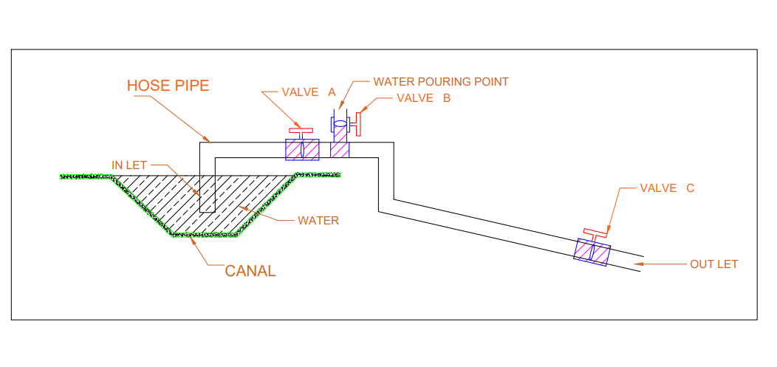

**INNOVATION:**

* To design Inlet and outlet gates/Valves such way that both gates open at a time. or we can open first inlet value and then open outlet value.
* To introduce water pouring point between inlet and outlet which helps to pour water in house pipes in rural areas

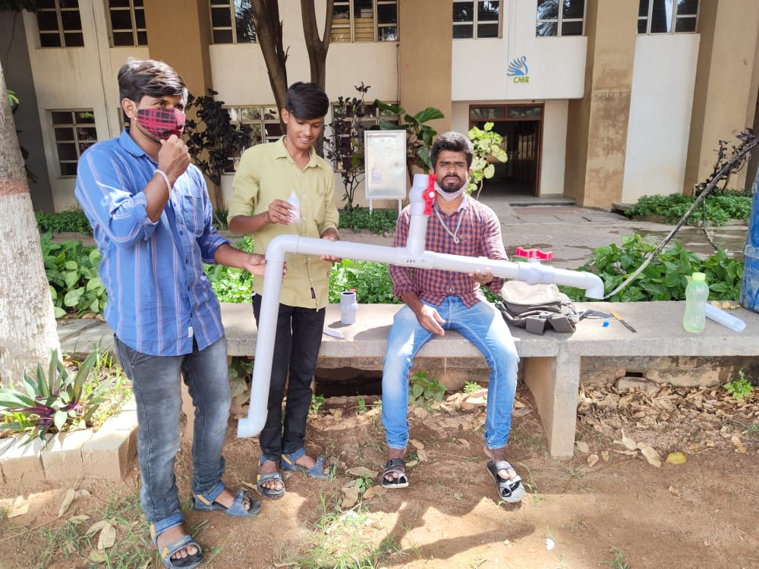

***APPARATUS;***

* We require canal at higher elevation(we used here water drum)
* 2 inch hose pipe of 20 ft or more
* 3 gates/valves
* 3 bents of 135 degree or 90 degree

**PROCEDURE:**

* First the connections should be made such that inlet of the pipe is inserted into canal(water drum) and outlet of the pipe is connected to field using 3 bents.
* We have to connect 3 valves (A,B &C) to hose pipe ,valve A is connected near inlet ,valve B connected at middle for pouring water, valve C is connected at outlet point.To introduce water pouring point Between inlet and outlet which helps to pour water in house pipes.

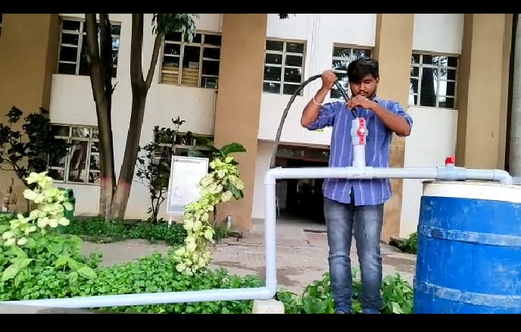

* First we have to close the inlet valve(A) and outlet valve(C) and open the valve B to pour the water.
* Pour the water until the hose pipe should be filled completely.Then we have to close the pouring point(valveB).
* After that we have to open Inlet and outlet gates/Valves such way that both gates open at a time or we can open first inlet valve(A) and then open outlet valve(C).
* The water will start coming out from the canal.
* No need to fill or pour the water every time into the hose pipe ,we have to fill only once. But if we want to stop the water we have to close only outlet valve(C) & pouring point.

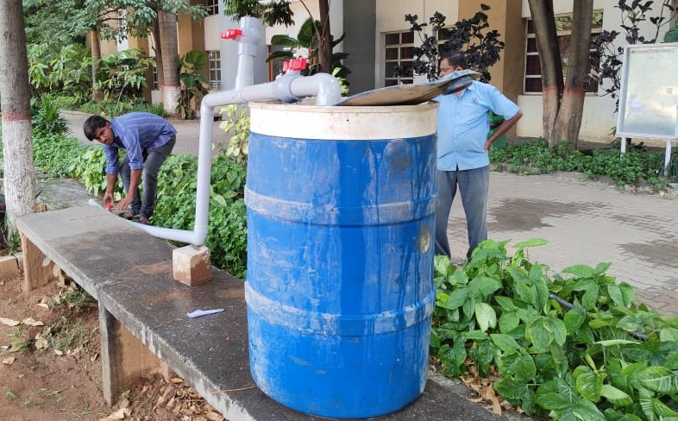

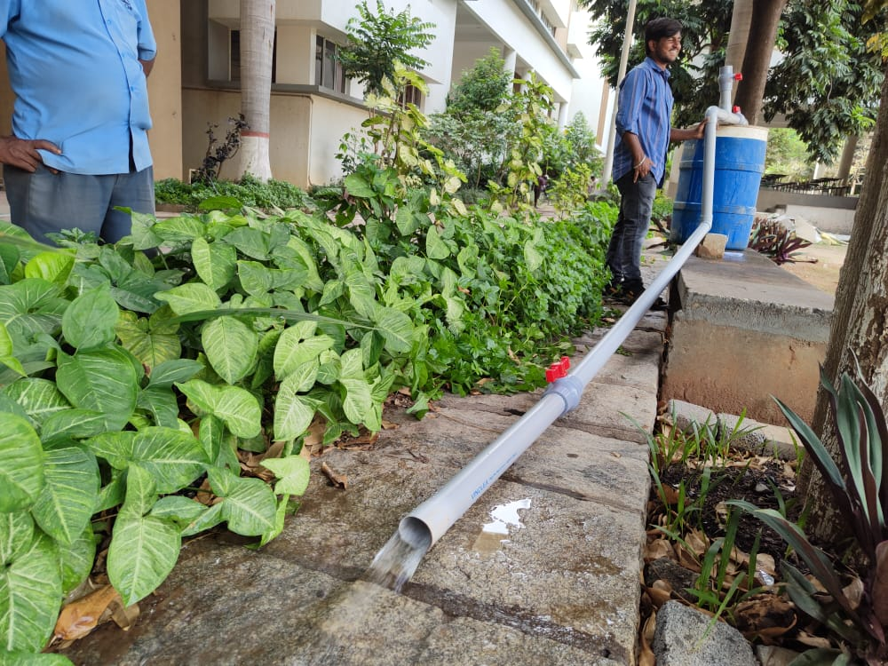

CONDITIONS:

Canals should be higher level then field

**MAJOR FINDINGS :**

* + Continuous suction pressure to be maintained in the hose pipe to draw water continuously.
  + Hose pipe should be air tight/no leakages.

**SOCIETAL BENEFITS:**

* + Ease the work of farmers/construction worker
  + Type of development is sustainable as it wont use any sort of power supply to draw water from canals.

**BENEFITS:**

* Helps Formers to draw water from irrigation canals in the locations where proper conveyance system is not developed.
* Helps to draw water from basements and dispose the water outside under favourable conditions to this method.

THANK YOU